August 20, 2012
Motocross Action Magazine News
GODSPEED DENNIS BOULWARE
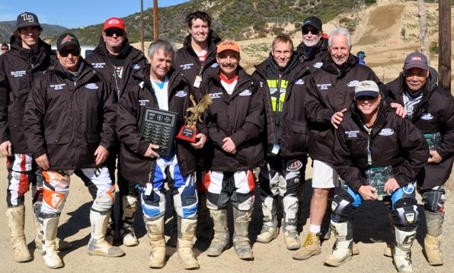
Dennis Boulware (center in orange hat) at the yearly REM trophy day back in January. Dennis raced his way up through the ranks to win the REM number one plate four times.
For those who race at Glen Helen Raceway Dennis Boulware was a household name. Dennis raced there almost every weekend of his life for the past couple decades. He was a fierce competitor and one of the toughest men on the planet to pass. You didn’t get by Dennis Boulware without rubbing shoulders, trading paint and muttering some swear words. And, Dennis Boulware was a successful motocross racer – he won four REM Glen Helen Number One plates (the most ever by a single rider) and raced is way through life, from a teenager to a 55-year-old man. And he never missed a beat, race or weekend...
Until this past weekend: Early in the morning, while practice was still going on Dennis complained of pain in his chest. Luckily, he was parked about 50 feet away from the ambulance and walked over to have them check him out. Once the EMT’s took his blood pressure they told him, “You are going to the hospital, right now.” There was no big drama and few riders at the track even had an inkling of what was taking place. In fact, because the ambulance pulled out without any commotion, it wasn't until the races started that word filtered back with the sad news.
Dennis was transported down the hill and to the front gate when his heart gave out. The EMT’s worked on him, but it was too late for the REM Champion. He passed away.
Dennis was a quiet man with great love for the sport and proud of his family. Dennis had been showing photos of his new grandchild that morning at sign-up. As at all races, the men who ply their trade on a weekend morning accept the risks of racing, but to lose a beloved competitor to a sudden and unexpected heart attack is not what most of us expect. Dennis might have accepted that kind of death in his old age, but for a man who was strong as a bull and twice as determined–it robbed us all of his friendship all too soon. Our sympathy and prayers for his family and friends... among which MXA counts itself.

